|  |  |  |  |  |  |
| --- | --- | --- | --- | --- | --- |
| **Entorn de test** | | | | | |
| Escenari: | Vivenda | REF: | building1 | Data: | 08/05/2015 |

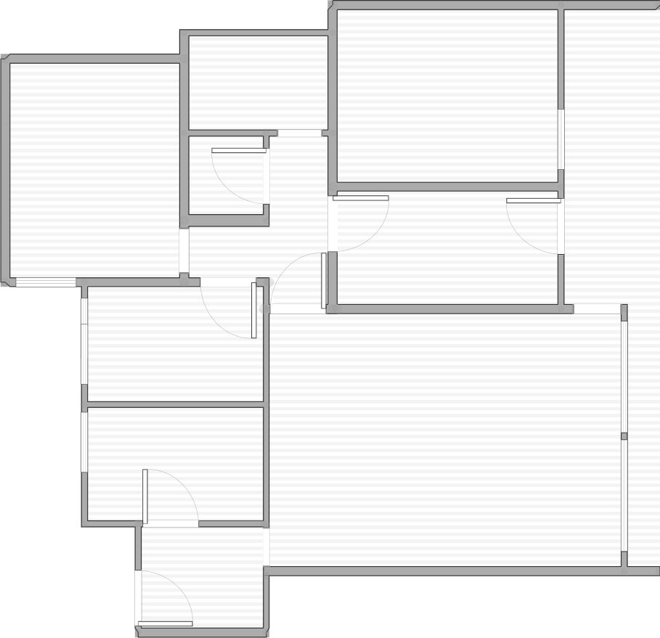**Plànol**

**B 5**

**B 1**

**B45**

**B 3**

10.37 m

**B 2**

(0, 0)

10.67 m

|  |  |  |  |  |  |
| --- | --- | --- | --- | --- | --- |
| ID | Beacon Unique ID | Beacon Address | Posició (cm) | | |
| x | y | z |
| B2 | V2fJ | D0:F8:F2:95:3A:5C | 975 | 155 | 160 |
| B1 | uCuI | D6:40:86:6D:BD:DF | 250 | 30 | 160 |
| B3 | Es2B | D9:A3:28:6A:A7:F1 | 445 | 560 | 160 |
| B4 | 63Us | F5:7A:A5:E3:EF:18 | 160 | 920 | 160 |
| B5 | CthW | FF:A6:7C:AF:B0:CB | 650 | 1010 | 160 |